Red-Black Tree

 | Time
Insertion | O(log n)
Deletion | O(log n)

A red-black tree is a type of binary search tree that colours its nodes red or black. It improves on the concept of a binary search tree in regards to its efficiency in searching, inserting and deleting. A binary search tree operates in O(h) time where ‘h’ refers to the tree height whereas a red-black tree operates in O(log n) time in the worst case. The main difference between a binary search tree and a red-black tree is that a red-black tree rebalances itself after a modification to keep a uniform height across the tree.

Red-Black Tree Properties
A valid red-black tree is one that satisfies the rules of a binary search tree:
- Any given node can have 0, 1 or 2 children at most
- All nodes that appear in the left sub-tree of a parent node must have a key smaller than that parent’s key
- All nodes that appear in the right sub-tree of a parent node must have a key greater than that parent’s key

In addition the following red-black tree conditions must be observed:
- Each node must be coloured red or black
- The root node must be black
- If a node is red then both of its children must be black
- All leaf nodes (the null pointers of a node) must be black
- From the root node to any leaf node (null pointer) there must be the same number of black nodes along that path

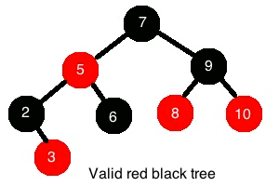

Iteration
Iteration from the lowest value key to the highest value key (thereby visiting each node exactly once) can be achieved by first obtaining a pointer to the node with the lowest value key.

Node *
nodeWithLowestKey(Node * node) {
while (node->left != NULL)
node = node->left;
return node;
}

Node * beginNode = nodeWithLowestKey(root);

This simply travels from the root node down each subsequent left child node until a null pointer is reached.

Now we attempt to find the next node in the sequence.

Node *
successor(Node * node) {
if (node->right != NULL) {
node = node->right;
while (node->left != NULL)
node = node->left;
}
else {
Node * parentNode = node->parent;
while (parentNode != NULL && node == parentNode->right){
node = parentNode;
parentNode = parentNode->parent;
}
node = parentNode;
}
}

(a) The next node is reached by first checking if the current node has a right child. If it does then we need to travel to the bottom left of the sub-tree of the right child to arrive at the next node in the sequence.

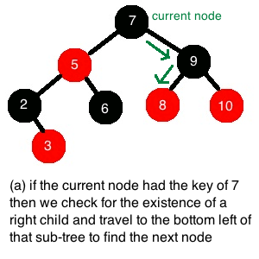
(b) If the current node doesn’t have a right child then we navigate up the tree from the current node to find the first parent node arrived at from a left child node and this will be the next node in the sequence.
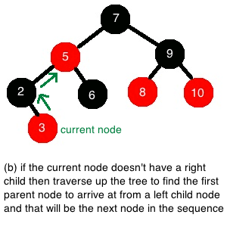

The end sentinel (the imaginary element one after the last element) ends up being the root’s parent (a NULL node pointer).

Modification
Insertions are a two-step process (so are deletions). First the new node is added (or removed) from the tree and then a ‘fix’ function is called to fix the tree. When modifying a red-black tree it is quite likely that one or more of the five properties are violated leaving the tree in an invalid state and so requires fixing before another operation on the tree is requested.

In order to fix the tree we use a combination of tactics of re-colouring nodes and altering the overall structure of the tree. We alter the structure by performing rotations on certain nodes since it is apparent that the same nodes can be reorganised in a slightly different way yet still abide by the principles of a binary and red-black tree. Bear in mind that the aim here is to keep an overall uniform height for the tree so that it keeps balanced and not lop-sided.

Rotation

When rotating a node left we assume that it has a right child (i.e. is not null). For example, take node n and its right child, node p. The link between them pivots to the left so that the right child, node p, becomes the parent of the original node, node n, and re-parents the left child of node p, called node o, to be the right child of node n. The nodes are still in an ordered state as only the structure has been modified at this point.

Note: a right rotation is also possible and is simply a symmetrical reverse of the concept of a left rotation.

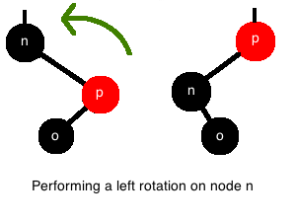
void
leftRotation(Node * node) {
Node * n = node;
Node * p = n->rightChild;
n->right = p->left;

if (p->left != NULL) {
p->left->parent = n;
}

p->parent = n->parent;

if (n->parent == NULL) {
root = p;
}
else if(n == n->parent->left {
n->parent->left = p;
}
else {
n->parent->right = p;
}

p->left = n;
n->parent = p;
}

Insertion
An insertion initially happens the same way as for a binary search tree. Since the tree is already sorted and valid the new node just follows the left or right path down from the root based on whether its key is less than or greater than the current node. Eventually it will attach itself as a leaf node.

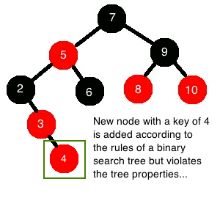

According to the rules of a red-black tree a new node is automatically coloured red when attached to the tree. It is now likely that the properties need to be checked for violations. In this example property 4 is violated (if a node is red, then both its children must be black) since node 3 is red and now has a red child in node 4.

There are three cases to consider when deciding how to fix a tree:

Case 1: The new node’s (node n) parent and uncle are red

- We know that node n’s grandparent must be black since it has red children (adhering to property 3) so we can swap the colours of node n’s parent and uncle to black and swap the grandparent to red.
- This fixes the sub-tree where the grandparent is the root but as the grandparent is now red then that may cause a violation further up the tree if the grandparent’s parent is also red (violating property 3 again)! So case 1 needs to be applied recursively up through the tree until this property is not violated anymore using each successive grandparent as the current node for the next recursive call.

Case 2: The new node’s (node n) uncle is black and node n is a right child
Case 3: The new node’s (node n) uncle is black and node n is a left child

- If case 2 applies meaning that node n is a right child and its uncle is black then we perform a left rotation on node n’s parent. This action neatly moves us into case 3 as essentially we have swapped the parent-child relationship with node n and its parent. Now the violating node’s uncle is still black but now it is a left child
- In case 3 we do some colour changes and a right rotation. At this point we know the violating node and its parent are red and the grandparent is black. First we set the parent to black, then we set the grandparent to red and finally we do a right rotation on the grandparent.

Void fixTree(Node * node) {
Node * n = node;

While (n->parent.colour == RED) {
If (n->parent == n->parent->parent->left) {
o = n->parent->parent->right;

// CASE 1
if (o->colour == RED) {
n->parent.colour = BLACK;
o.colour = BLACK;
n->parent->parent.colour = RED;
n = n->parent->parent;
}
// CASE 2
else if (n == n->parent.right) {
n = n->parent;
leftRotation(n);
}
// CASE 3
n->parent.colour = BLACK;
n->parent->parent.colour = RED;
rightRotaion(n->parent->parent);
}
else {
//same as IF above but with “right” and “left” exchanged
}
} // end while
root.colour = BLACK;
}

Deletion

